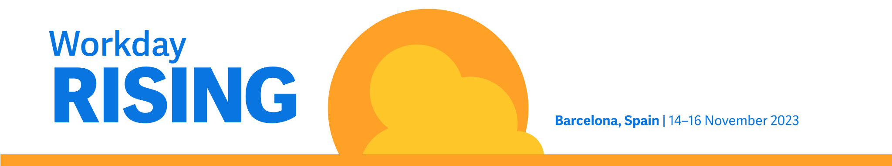

Workday Rising EMEA – request to attend

Hello [Name],

I’m requesting your approval to attend Workday Rising EMEA, taking place on 14–16 November at CCIB, Barcelona, Spain. Workday Rising EMEA is a window into how the future works, how AI and machine learning are shaping the world of tomorrow and the innovation needed to succeed in a changing world. This is a great opportunity for me to see first-hand what differentiates Workday from other finance and HR systems, as well as get inspiration for solving our own business challenges.

In 2022, Workday Rising Europe had more than 3,600 attendees, over 69 partner companies in the Expo and hundreds of educational sessions. Organisations evaluating Workday are invited to attend the entire conference experience free of charge. I’ll get to make valuable connections, hear how other organisations use Workday and meet one-on-one with industry leaders and product experts.

Specifically, I’d like to focus on exploring solutions or best practices that could benefit the following projects at our organisation:

- [add project or initiative]

Here’s a breakdown of my approximate conference costs based on flying into Barcelona:

Item | Approx cost
Average airfare | €300
Transport: A round-trip taxi from the airport to CCIB and adjacent hotels from the airport | €80
Hotel: Three nights at €200 | €600
Meals/expenses: Breakfast and lunch provided daily, along with two dinner events provided, three days at €60 | €180
TOTAL | €1,160

I’m confident that attending Workday Rising EMEA will help us make an informed technology investment. After the conference, I’ll summarise what I’ve learned and share with key stakeholders throughout the company.

Thanks in advance for considering my request.

