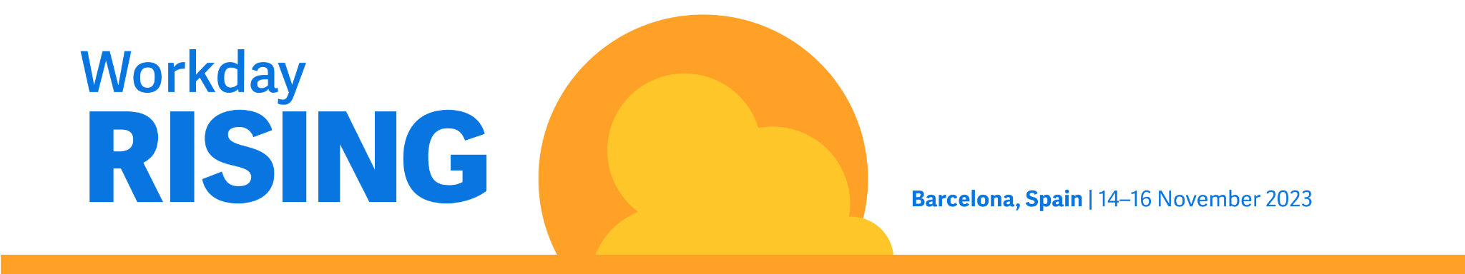

Workday Rising EMEA – request to attend

Hello [Name],

I’m requesting your approval to attend Workday Rising EMEA, taking place on 14–16 November at CCIB, Barcelona, Spain. Workday Rising EMEA is a window into how the future works and how AI and machine learning are shaping the world of tomorrow. This is a great opportunity for me to experience the innovation needed to succeed in a changing world and see how our organisation can adapt for our continued success.

Attending Workday Rising EMEA will allow me to connect with the whole customer community while learning about the latest innovation from Workday. I’d love to collaborate with other customers, meet one-on-one with industry and product experts and boost my professional development.

Specifically, I’d like to focus on exploring solutions or best practices that could benefit the following projects at our organisation:

- [add project or initiative]

Here’s a breakdown of my approximate conference costs based on flying into Barcelona, including a special discount of €200 off the regular conference pass for Early Bird registration:

Item | Early Bird  (Until 19 September at 17:00 CEST) | Regular  (From 17:01 19 September)
Average airfare | €300 | €300
Transport: A round-trip taxi from the airport to CCIB and adjacent hotels from the airport | €80 | €80
Hotel: Three nights at €200 | €600 | €600
Meals/expenses: Breakfast and lunch provided daily, along with two dinner events provided, three days at €60. | €180 | €180
Registration fee | €1,595 +VAT | €1,795 +VAT
TOTAL | €2,755 | €2,955

I’m confident that Workday Rising EMEA will benefit our organisation, our team and me. After the conference, I’ll summarise what I’ve learned and share next steps with key stakeholders throughout the company.

Thanks in advance for considering my request.

